## **Lithotripters:**

* A lithotripter is a **non-invasive device that breaks up kidney stones by passing electromagnetic shock waves through** a water bath while a patient sits inside.
* The lithotripter provides a nonsurgical means of pulverizing stones into pieces small enough to be passed naturally in the patient's urine.

**The Shockwave:**

* The shock wave is a short pulse of about 5 μs duration. Typically, the wave begins with a near instantaneous peak pressure of about 40 MPa.
* This fast transition in the wave form is referred to as “**shock**”
* The transition is faster than can be measured and is less than 5 ns in duration.
* The pressure then falls to zero about 1 μs later. There is then a region of negative pressure that lasts around 3 μs and has a peak negative pressure around 10 MPa.
* The amplitude of negative pressure is always less than the peak positive pressure, and the negative phase of the waveform generally does not have a shock in it i.e. there is no abrupt transition.
* The entire 5 μs pulse is generally referred to as a shock wave or shock pulse or pressure pulse.
* Lithotripters produce a similarly shaped shock wave. Depending upon the machine and the setting, the peak positive pressure typically varies between

30 and 110 MPa and the negative pressure between -5 and -15 MPa

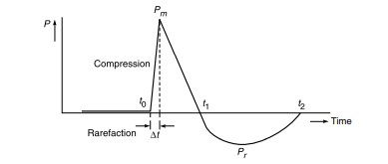

Schematic of an acoustic shock wave pulse

* Lithotripters produce a powerful acoustic field that results in two mechanical forces on stones and tissue (i) direct stress associated with the high amplitude shock wave and (ii) stresses and microjets associated with the growth and violent collapse of cavitation bubbles
* Shock waves are generated and then focused onto a point within the body. The shock waves propagate through the body with negligible dissipation of energy (and therefore damage) owing to the minimal difference in density of the soft tissues.
* At the stone-fluid interface, the relatively large difference in density, coupled with the concentration of multiple shock waves in a small area, produces a large dissipation of energy.
* Using various mechanisms, this energy is then able to overcome the tensile strength of the calculi, leading to fragmentation. Repetition of this process eventually leads to pulverization of the calculi into small fragments (ideally < 1 mm) that the body can pass spontaneously and painlessly

**The Lithotripter Machine:**

* The principle of the first lithotripter machine is from **Dornier medical systems**, pioneers in the field of lithotripsy.
* It consists of a large tub of warm water with the underwater electrode (spark plug) in the ellipsoidal reflector at the base of the tub.
* The water provides an acoustic coupling to the patient so that acoustic waves generated in the water penetrate the tissue and are not reflected from the skin.
* A single acoustic wave generated by the lithotripter is of high amplitude compared with those used in normal medical diagnostic ultrasound, it propagates in a characteristic way.

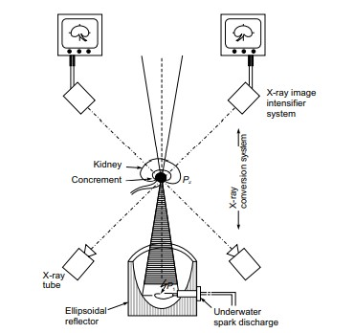

Construction for extracorporeally induced destruction of kidney stone with integrated x-ray positioning system

* The shock wave is produced when an electrical discharge occurs between two electrodes in water.
* The energy deposited in the water from the electrical discharge produces a bubble of very hot, rapidly expanding plasma which subsequently collapses after emitting a shock wave.
* This wave, which expands out from the electrode gap, is focused using a hollow, hemi-ellipsoidal brass reflector.
* Since an ellipse has two foci, a spherical wave initiated at one of the foci will be focused after reflection at the second.
* The point of shock wave generation is at point P1 of an ellipsoid, half of which constitutes the reflector at the base of the water bath tub.
* Through the focusing of the shock- waves, the energy is concentrated at the second focus P2 of the ellipsoid.
* In the Dornier machine, this point is about 15 cm above the upper edge of the ellipsoid.
* The patient is moved, partially submerged in the bath tub, on a hydraulically operated gantry until the stone is accurately positioned at the second focus of the ellipsoid by using bi-planar fluoroscopy.
* The positioning system of the Dornier lithotripter uses two independent X-ray systems with separate axes.
* The orthogonal X-ray beams, from X-ray tubes positioned under the bath tub, are viewed by two image intensifiers, resting on the patient’s lower abdomen, and the resulting images are displayed on two monitors.
* The crossing point of the X-ray beam axes is the second focus of the shock wave reflector, the stone is correctly centred when it appears at the same position on both monitors which is indicated by cross-wires of each X-ray system.
* The stone is possibly broken up by stress and shear forces generated in it by a series of shock-waves, though other mechanisms may also be involved including a phenomenon known as ‘cavitation’

### **Modern Lithotripter Systems:**

* Modern machines incorporate clinical advantages over their predecessors.
* The integration of a variety of reflector sizes and control over voltage and power output allows for greater ease of use as well as customization of treatment parameters for increased treatment efficiency and decreased discomfort for the patient.
* The main components of a lithotripter system are:
* Focused shock wave source;
* Means for acoustic coupling of the shock wave to the body;
* Imaging modalities for stone localization and therapy control;
* A patient table with either the table or the shock wave source movable in three dimensions
* System for the measurement of physiological variables and their monitoring; and
* Trigger generation and control system

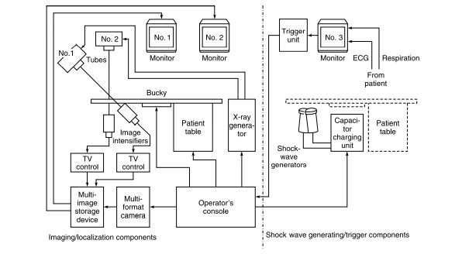

Schematic diagram of a lithotripter system with biplane X-ray imaging

**Shock wave Generator**

* Electrohydraulic:
* The original method of shock wave generation is produced via spark gap technology.
* In an electrohydraulic generator, a high-voltage electrical current passes across a spark-gap electrode located within a water-filled container.
* The discharge of energy produces a vaporization bubble, which expands and immediately collapses, thus generating a high-energy pressure wave.
* The burning of electrodes results in significant variation of the different shock waves applied at the same generator settings (generator power) and necessitates electrode exchange after a few treatments.

**Focusing Systems**

* Shock waves in lithotripsy is strongly focused in order to keep the area of interaction with tissue or concernments restricted to the predetermined region of interest.
* Any tissue in front of, behind or adjacent the target area should be left unaffected.
* This medical requirement uses a large aperture systems which spread the shock wave energy over a wide skin entrance area.
* Simultaneously, the system concentrates the acoustic energy precisely to a small focal volume with a cross-sectional diameter of a few millimeters.
* Modern systems use aperture angles of 80 to 90 degrees to provide these favourable field parameters.
* Focusing systems differ, depending on the shock wave generator used.
* Electrohydraulic systems used the principle of the **ellipse**; a metal ellipsoid directs the energy created from the spark-gap electrode.
* In piezoelectric systems, ceramic crystals arranged within a **hemispherical dish** direct the produced energy toward a focal point. In electromagnetic systems, the shock waves are focused with either an acoustic lens or a **cylindrical reflector**.

**Shock Wave Sources**

* The three basic types of shock wave sources for lithotripsy are:
* Plasma explosion method (Electrohydraulic); • Electromagnetic system;
* Piezo-ceramic system.
* These excitation sources are coupled with the following focusing methods: (a) Ellipsoidal reflector; • (b) Focusing with an acoustic lens; and
* (c) Self-focusing source.

**Plasma Explosion Method:**

* Shock wave generation by plasma explosion over a high-voltage spark gap in water, was the pioneering method with which the first Dornier extra-corporeal shock wave Lithotripters were operated.
* In this method, a capacitor is discharged across two opposing electrodes placed at the first focus of a partial ellipsoid of rotation in a bath tub.
* A conducting plasma channel is formed between the electrodes and expands with supersonic velocity. The resulting compression wave in the water is a shock wave with a steeply rising front.
* The initial velocity of the radial propagation of the shock wave is significantly higher than the normal speed of sound in water, but rapidly slows down towards it.

**Coupling**

* A medium is used for coupling shock waves to the human body to minimize the presence of air to provide undisturbed propagation of the acoustic pulse and to obtain good matching of acoustic impedance to the acoustic impedance of the human skin to minimize reflection of the acoustic pulse at the skin.
* An open bath tub provides optimal acoustic coupling, but restricts positioning and handling of the patient.
* It necessitates the management of large volumes of clean water and adequate safety measures to reduce electrical hazards to the patient
* Efficient transfer of acoustic energy from one medium to another only occurs when the acoustic impedances are very close.
* A water/tissue interface results in very good coupling and therefore, the first-generation Lithotripters used an open water bath in which the patient was immersed.
* Most current Lithotripters have the shock wave source mounted in a therapy head, which is filled with water. The therapy head is capped by a thin rubber membrane pressed against the patient and through which the shock wave passes.
* A coupling agent such as gel or oil is smoothed on the rubber membrane and the patient’s skin to ensure good coupling by reducing air pockets

**Imaging**

* X-ray fluoroscopy as well as ultrasound B-scan are used as sole imaging procedures in lithotripsy.
* For pre-treatment diagnosis and for immediate and long-term control after the shock wave treatment, X-ray imaging is the best method.
* For optimal fluoroscopy, two X-ray generators and image intensifiers are used at different imaging planes. The radiological image appears on the high resolution computer screen mounted on the control panel. Using digital image control, the computer can enhance the contrast of the calculus, and can also save an entire series of images on the magnetic media during the treatment

**Patient Table**

* For treatment, the patient is positioned on a treatment table, where the stone is localised by means of an imaging system, and the focal point of the shock wave source is positioned by moving the patient or the shock wave source.
* A couple of thousand shock waves are applied with a frequency of 60 to 120 shots per minute resulting in a treatment time of nearly one hour.
* Stone position and disintegration is checked routinely using the imaging system
* Shock wave sources are arranged below the structures supporting the patient.
* For aiming the focus at the concrement, either the table with the patient is moved or, after an approximate positioning, the shock wave source is adjusted.
* With two symmetrically arranged shock wave sources, the patient lies in a supine position independent of whether the left or right kidney is treated.
* The patient table is motorized that enables movement in all three directions. The table can be controlled directly from the control panel.
* It provides the ability to position the patient in three co-ordinate axes and provides access to the patient’s lumber area.
* The table has an opening permitting the patient’s lumber area to contact an oil-coated membrane that acoustically couples the patient with the water system

**Monitoring and Trigger Generation**

* Monitoring of the heart is nevertheless advisable because even when treatment is performed with a lithotripter, circulatory reactions, such as extra-systoles are found to occur in a low percentage of the patients.
* In these cases, triggering of the shock waves by the heart cycle is used as a preventive measure.
* Any ECG monitor that provides a 1-volt TTL R-wave sync or defibrillation sync output signal can be used for the required synchronization of the shock waves with a patient’s heartbeat.

## **Infusion Pumps:**

### **Components of Drug Infusion Systems**

* The drug infusion systems basically consist of two components: a mechanism that delivers the drug, and a means of controlling the rate of delivery.
* In open loop systems the rate of delivery is set by the nurse or physician on the basis of past experience, mathematical computation, or by trial and error.
* The fluid is delivered at the set rate until the setting is changed.
* In closed loop systems, the effects of the drugs are monitored by appropriate transducers, and the desired delivery rate is computed and set automatically.

**Delivering the Drug**

* The traditional and simplest intravenous infusion systems consist of a

fluid container, administration set, and a clamp to control the flow from the set to the patient.

* The driving pressure is the difference between the hydrostatic pressure generated by the column of liquid in the administration set, and the venous pressure.
* Since the latter is typically 4-8 mm Hg, the driving pressure is approximated by the level of reservoir, usually adjusted to be 60-100 cm above the patient.
* The major difficulty with traditional intravenous infusion systems is that the flow rate cannot be accurately controlled.
* The flow rate is counted in drops rather than measured volumetrically. The rate is difficult to adjust, and even if adjusted correctly at first, it will change with time.
* Intravenous ‘controllers’ are mechanical or electrical devices that automatically control the flow rate of fluids, even though the driving pressure is still generated by gravity. These sets contain chambers and valves that meter fixed volumes of liquid for infusion.
* The devices generally raise an alarm when malfunctions such as empty container, occlusion, or low battery are detected.
* Infusion pumps, rather than depending on gravity to generate flow develop pressure by one of several electro-mechanical means.

**Syringe Pumps**

* In syringe pumps a motor, through a gear-reducing mechanism and a lead screw, applies force to the plunger of a syringe containing the drug.
* The device is mainly convenient for applications that require the delivery of volumes limited by the syringe size
* Syringe pumps are usually of a reciprocating type. A plunger or piston delivers a fixed volume of fluid on each stroke.
* They require valves and normally furnish a pulsating flow which can be evened out by the use of reservoirs or by polyplex arrangements in which the discharge portion of the stroking cycle is spread over more than the conventional 180°.
* Piston pumps can be used at high pressures. Control is achieved by varying the stroke length or the stroke rate.

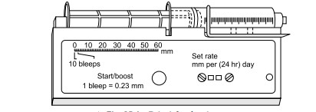

Principle of Syringe Pump

* **Peristaltic Pumps**
* These pumps squeeze a flexible bag or tube to produce movement of the liquid inside the compressed container.
* Linear peristaltic pumps have a row of fingers that compress the tube in a wave-like motion, squeezing the liquid as the wave progresses.
* The more often used rotary peristaltic pumps use a rotor that pushes rollers against a tube along a semi-circular path.
* Peristaltic pumps have the advantage that the fluid does not come into contact with the pump, avoiding contamination.
* If true volumetric pumps are required, however, special tubing must be used.

**Implantable Infusion Systems:**

* Implantable infusion pumps are battery powered devices that are surgically implanted to provide continuous drug delivery for various ailments in patients.
* These pumps apply a known pressure to a reservoir of the drug, and there is a high-resistance connection between the pump and site where the drug is to be delivered, which is usually a vein.
* The high resistance connection is generally a long, thin capillary tube that is wound around the periphery of the pump.
* The constant pressure in the reservoir and the fixed resistance of the tube maintains a steady but slow rate of infusion of the drug into the venous circulation.
* These pumps, therefore, utilize a concentrated form of the agent to be infused.
* The implantable infusion pump has three basic parts:
* (i) pump, (ii) catheter, (iii) programmer.
* The **pump** stores and releases prescribed amounts of drug. It is contained in a round metal housing about one inch thick and three inches in diameter; it weighs about six ounces.
* The major components are a miniature peristaltic pump, drug reservoir, battery, antenna, and microprocessor.
* The pump is implanted surgically, usually in or near the abdomen, and can be refilled through the skin with a needle and syringe.
* The **catheter** is a small-diameter silicone rubber tube that is tunnelled under the skin from the pump to the drug delivery site
* A programmer is used by the physician to externally program and reprogram the pump, the device is run by a portable computer with special software.
* It has a hand-held device that transmits instructions by radiotelemetry to the pump.
* The pump can be programmed from outside the body, and is easily adjusted to the patient’s changing needs.
* A clinician uses a programmer to set and/or adjust the dosage, drug flow rate, and other variables. The pump offers various delivery patterns, including a straight continuous-flow pattern, or a more complex pattern that allows varying the dose at different times of the day to meet the patient’s changing requirements

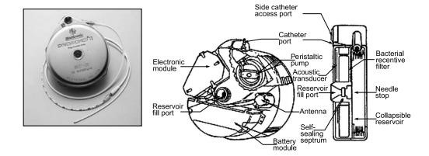

Implantable infusion pump

Examples of Infusion Pumps

**Drop Rate Counter Type Infusion Pump**

* The device consists of three major components: the fluid reservoir, a catheter system for transferring fluids into the body and a device that combines electronics with a mechanism to generate and regulate flow.
* The heart of the system is a customized digital (LSI) device which performs all the logic functions.
* It operates under the control of a clock frequency of 71.68 kHz obtained from a crystal-controlled oscillator which provides various timing and control signals.
* The drop sensor is attached to the administration set drip chamber and closes the servo loop by providing rate feedback information

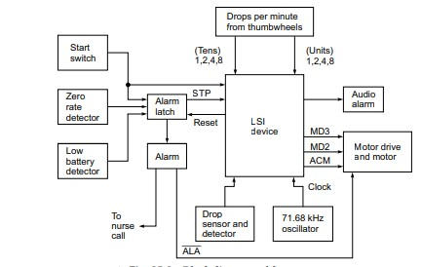Block diagram of drop rate counter

* The drop sensor contains an array of light emitting diodes (LEDs) and phototransistors which generate a signal each time a drop of IV fluid falls into the drip chamber.
* This signal is applied to the drop detector which causes the drop indicator to flash
* Four signals are required to activate and run the motor: ALA, ACM, MD2 and MD3. These signals except ALA are developed within the LSI device. ALA is a logical “1” when the unit is not in alarm.
* Activate motor (ACM) is the variable width signal which applies power to the motor. Motor drive (MD2 & MD3) signals are outputs from the LSI device which provide quadrature voltage to the motor
* Each time the motor is activated by ACM, a series of MD2 and MD3 pulses is obtained.
* ACM increases in width each time the motor is pulsed and more MD2 and MD3 signals are applied.
* This causes the motor to run for longer periods. When a drop is sensed, the width of the ACM is reduced thereby decreasing the number of MD2 and MD3 pulses applied to the motor. This is the servo action
* The pulse width of ACM is internally limited to prevent the pump from producing a steady flow condition of IV fluid
* When an external circuit signals the unit to alarm, a stop STP signal is generated stopping the motor from stepping.
* Two thumbwheels are used to set the desired rate (drops per minute) in terms of ‘tens and units.
* A zero-rate detector causes the unit to alarm if the drops per minute detector is inadvertently set to 00.
* When the unit goes to alarm for any reason an audible alarm signal is produced. When operating on a battery power, the low battery alarm puts the unit into alarm when the battery voltage drops to a predetermined minimum level.
* This prevents inaccurate or erratic operation because of low voltage conditions
* A processor with an advanced graphical user interface, smart and Realtime physiological processing and wired and wireless connectivity options for patient monitoring and data logging applications provide an additional level of safety by quickly detecting complications and generating an alarm.

**Programmable Volumetric Infusion Pump**

* Volumetric implies flow rate calibration in units of known volume, ml/hr, rather than non-volumetric units of drops/minutes.
* It incorporates a peristaltic (tube squeezing) pump mechanism. The flow rate is calibrated on known inner diameter tubing.
* Flow rate is a function of pump speed, tubing inner diameter, and tubing elasticity.
* The flow rate tolerances are almost totally controlled by the inner diameter dimensional variations of the sets used. The speed of the

pump is maintained electronically within ± 0.1%

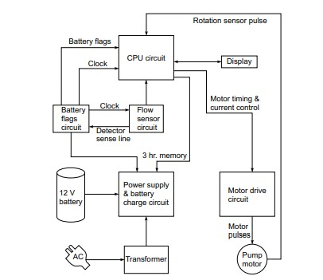

Block diagram of the programmable volumetric infusion pump

* The heart of the system is a central processing unit. It has a 2.5 MHz external clock supplied by a crystal.
* The CPU outputs a stream of pulses for operating the motor drive circuit.
* An ultrasonic sensor is used to detect the drop which then signals to the microprocessor that a drop has been detected by the flow sensor.
* The ultrasonic signal is amplified and de-modulated before it is given to an 8-bit A/D converter. The A/D converter is controlled by the microprocessor
* The feedback from the pump motor to the CPU, is sensed by a hall effect sensor to sense the rotation
* The transducer gives a single pulse per revolution and is mounted on top of the pump assembly.
* The door opened/closed signals are generated by hall effect switches.
* A circuit is incorporated to prevent the improper operation of the pumping mechanism that could result from a loop outside of the programme or failure and a subsequent lock-up of the microprocessor.
* The flow rate is set using a membrane type key pad which is connected to the microprocessor through a key board decoder.